Input Validation Issues Part -1

Navigate to the challenge

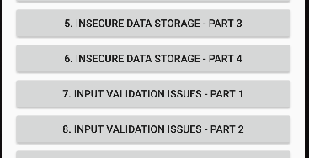

This is the challenge preview

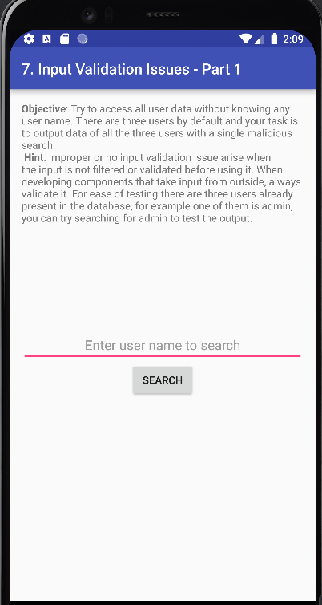

Since this challenge contains input validation issues, let’s try SQL injection. We can first check how the application react to (‘)

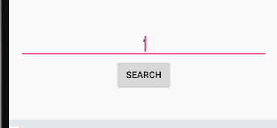

We get an error in logcat for this



Let’s try with (‘’)

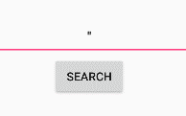

This give us an error that user is not found, indicating that we can exploit vulnerability using SQL injection



A simple SQL injection command should reveal the users in the application database

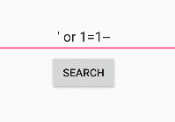

And we get our answer

